Flood Risk Prediction Using Machine Learning and Neural Networks

1. Introduction
This project developed a Flood Risk Prediction System using machine learning and deep learning techniques to classify flood risk into Low, Medium, and High categories based on environmental and climate-related factors.

2. Dataset Description
The dataset contains 20 environmental and infrastructure features. SMOTE was applied to handle class imbalance before training. The data was split into 80% training and 20% testing sets.

3. Models Used
Six models were evaluated: Logistic Regression, KNN, Decision Tree, Random Forest, XGBoost, and Neural Network.
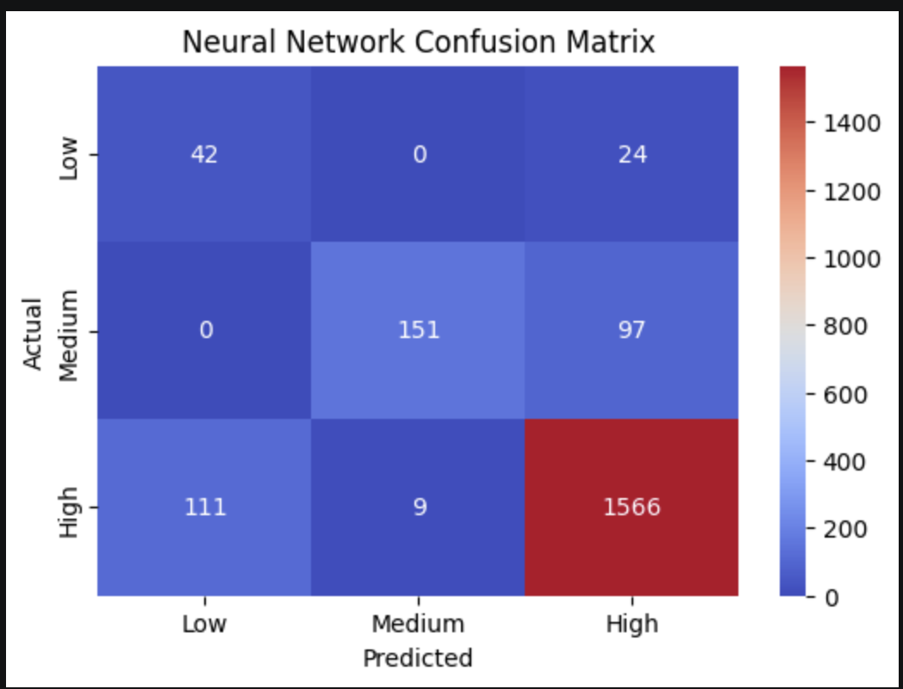

4. Neural Network
The Neural Network was implemented using TensorFlow/Keras with Dense layers, ReLU activation, Dropout regularization, and a Softmax output layer.
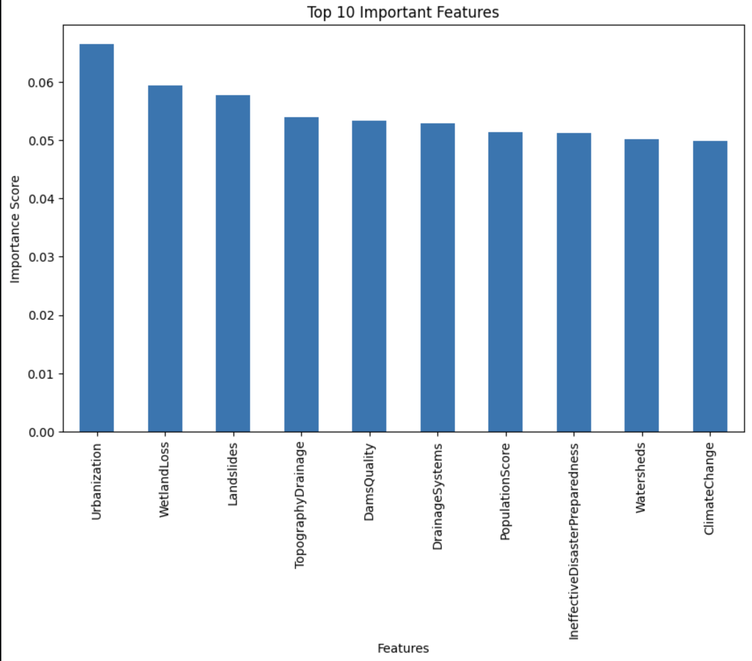

5. Results & Comparison
The Neural Network achieved the highest overall performance with Accuracy = 87.95% and F1-Score = 0.8872, outperforming the other evaluated models. Therefore, it was selected as the final deployment model and integrated into a Streamlit web application.

6. Important Features
Feature importance analysis showed that Urbanization, Wetland Loss, and Landslides were among the most influential factors affecting flood risk prediction.
